2. Создать средствами SQL Management Studio БД с двумя таблицами по следующей схеме:
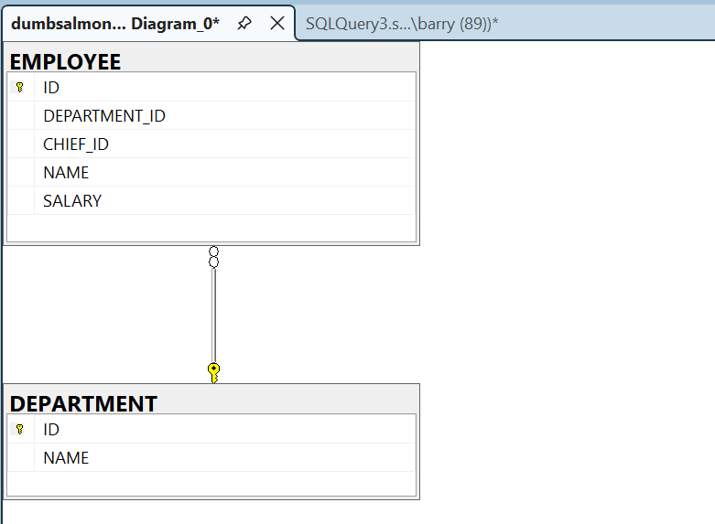
3. Заполнить эти таблицы произвольными данными (сотрудников не менее 15, отделов не менее 3). Для руководителей оставить поле «CHIEF_ID» пустым (NULL). Прислать выгрузку данных из двух таблиц.
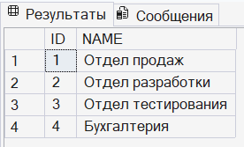
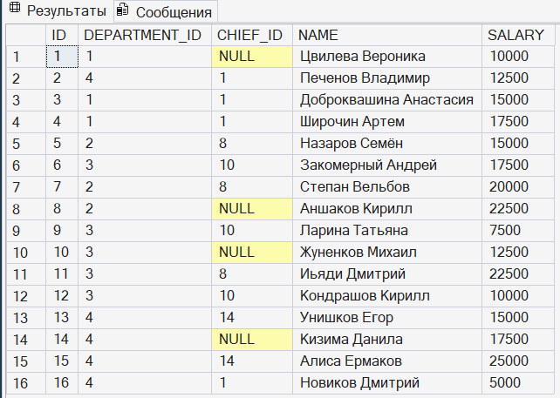
4.1 Вывести список сотрудников, которые получают заработную плату ниже, чем у непосредственного руководителя.
SELECT
e.name AS [Сотрудник],
e.salary AS [ЗП Сотрудника],
c.name AS [Руководитель],
c.salary AS [ЗП Руководителя]
FROM employee AS e
INNER JOIN employee AS c
ON e.chief_id = c.id
WHERE e.salary < c.salary

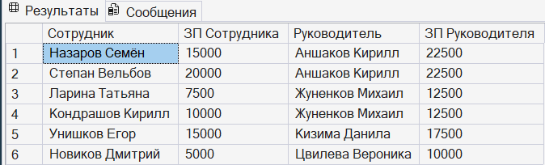
4.2 Вывести список сотрудников, которые получают минимальную заработную плату в своем отделе.
SELECT
e.name AS [Сотрудник],
e.department_id AS [ID Отдела],
e.salary AS "ЗП"
FROM employee AS e
WHERE e.salary = (
SELECT MIN(ms.salary)
FROM employee AS ms
WHERE ms.department_id = e.department_id)

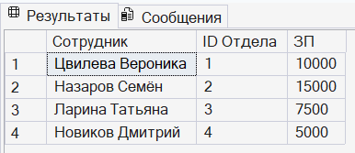
4.3 Вывести список ID отделов, количество сотрудников в которых не превышает трех человек.
SELECT department_id AS [ID Отдела], COUNT(name) AS [Количество сотрудников]
FROM employee
GROUP BY department_id
HAVING COUNT(name) <= 3

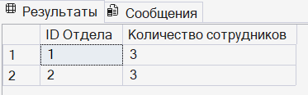

4.4 Вывести список сотрудников, не имеющих назначенного руководителя, который работал бы в том же отделе.
SELECT
e.name AS [Сотрудник],
e.department_id AS [Отдел],
c.name AS [Руководитель],
c.department_id AS [Отдел руководителя]
FROM employee AS e
INNER JOIN employee AS c
ON e.chief_id = c.id
WHERE e.department_id <> c.department_id

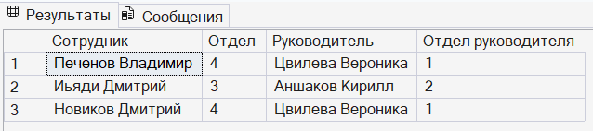

4.5 Вывести список сотрудников, не имеющих назначенного руководителя, который работал бы в том же отделе.

SELECT department_id AS [ID Отдела], SUM(salary) AS [Суммарная ЗП]
FROM employee
GROUP BY department_id
HAVING SUM(salary) = (SELECT MAX(max_salary)
FROM (SELECT SUM(salary) AS max_salary
FROM employee
GROUP BY department_id)
AS department_salary)

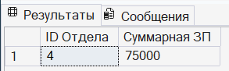

4.6 Составить SQL-запрос, вычисляющий сумму ЗП по отделам.
SELECT d.name AS [Отдел], SUM(e.salary) AS [Сумма ЗП отдела]
FROM employee AS e
INNER JOIN department AS d
ON e.department_id = d.id
GROUP BY d.name
ORDER BY [Сумма ЗП отдела] DESC

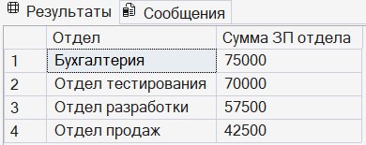

5. Реализовать хранимую процедуру (UPDATESALARYFORDEPARTMENT)

CREATE OR ALTER PROCEDURE UpdateSalaryForDepartment
@p_department_id INT,
@percent INT
AS
BEGIN
SET NOCOUNT ON;

DECLARE @val_chief_id INT;
DECLARE @max_salary INT;

IF @percent <= 0
BEGIN
THROW 50001,
N'Процент для повышения не может быть отрицательным или нулевым',
1;
END;

IF NOT EXISTS (
SELECT d.id
FROM department AS d
WHERE d.id = @p_department_id
)
BEGIN
THROW 50002, N'Выбранного отдела не существует', 1;
END;

SELECT @val_chief_id = e.id
FROM employee AS e
WHERE @p_department_id = e.department_id
AND e.chief_id IS NULL;

SELECT e.id, e.salary AS old_salary
INTO #old_salaries
FROM employee AS e
WHERE @p_department_id = e.department_id;

UPDATE e
SET salary = CAST(ROUND(salary * (1 + @percent / 100.0), 0) AS INT)
FROM employee AS e
WHERE @p_department_id = e.department_id AND e.id <> @val_chief_id;

SELECT @max_salary = MAX(e.salary)
FROM employee AS e
WHERE @p_department_id = e.department_id;

IF (
SELECT e.salary
FROM employee AS e
WHERE e.id = @val_chief_id) < @max_salary
BEGIN
UPDATE e
SET salary = @max_salary
FROM employee AS e
WHERE e.id = @val_chief_id;
END;

SELECT
e.id AS [ID],
e.department_id AS [ID Отдела],
e.chief_id AS [ID Руководителя],
e.name AS [Сотрудник],
os.old_salary AS [Старая ЗП],
e.salary AS [Обновленная ЗП]
FROM employee AS e
INNER JOIN #old_salaries AS os
ON e.id = os.id
WHERE @p_department_id = e.department_id
ORDER BY e.id;

DROP TABLE #old_salaries;
END;

